**University of Michigan – Dearborn**

**Department of Computer and Information Science**

**CIS 150L – Fall 2014**

Lab 8

Srinivas Simhan

11/03/14

**Table of Content**

1. Question 1 3
   1. Screenshot 3
   2. Source Code 3
2. Question 2 4
   1. Screenshot 4
   2. Source Code 4
3. **Question 1**
   1. **Screenshot**

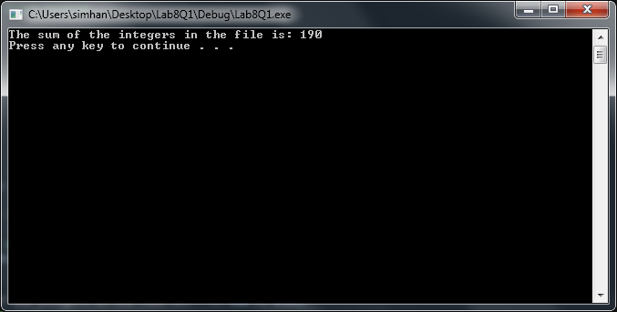

* 1. **Source Code**

// Purpose: Compute Sum of Integers in File

// Author: Srinivas Simhan

// Creation Date: 11/3/14

// Last Modification Date: 11/3/14

#include <iostream>

#include <cmath>

#include <string>

#include <fstream>

using namespace std;

int main()

{

int sum = 0, tmp;

ifstream inx;

inx.open("in.txt"); // open the file in.dat

while (!inx.eof()) // did we reach the eof() of the file

{

inx >> tmp; // grab one integer from the file

sum = sum + tmp; // update sum

}

cout << "The sum of the integers in the file is: " << sum << endl;

inx.close(); // close the file

system("pause");

return 0;

}

1. **Question 2**

**2.1 Screenshot**

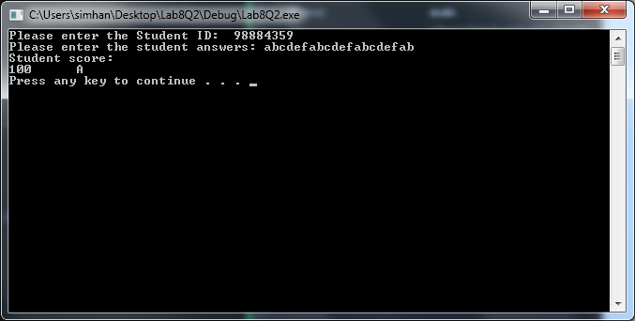

**2.2. Source Code**

// Purpose: Grade Checker

// Author: Srinivas Simhan

// Creation Date: 11/3/14

// Last Modification Date: 11/3/14

#include <iostream>

#include <cmath>

#include <string>

#include <fstream>

using namespace std;

float computeScore(string);

char determineGrade(float);

const int NB_QUESTIONS = 20;

const string ANSWER_KEY = "abcdefabcdefabcdefab";

int main()

{

string ID, answer; char finalGrade;

float score;

cout << "Please enter the Student ID: ";

cin >> ID;

cout << "Please enter the student answers: ";

cin >> answer;

score = computeScore(answer);

finalGrade = determineGrade(score);

cout << "Student score: " << endl << finalGrade << " " << score << endl;

system("pause");

return 0;

}

// Purpose: Compute Score

// Author: Srinivas Simhan

// Creation Date: 11/3/14

// Last Modification Date: 11/3/14

float computeScore(string answer)

{

float score;

int correct = 0;

for (int i = 0; i < NB_QUESTIONS; i++)

{

if (ANSWER_KEY.at(i) == answer.at(i))

{

correct++;

}

}

score = (correct * 100) / NB_QUESTIONS;

// this function compares answer to ANSWER_KEY,

// character by character

// counts the number of correct answers and returns

// the score (out of 100)

// COMPLETE CODE HERE

return score;

}

// Purpose: Determine Grade

// Author: Srinivas Simhan

// Creation Date: 11/3/14

// Last Modification Date: 11/3/14

char determineGrade(float score)

{

char grade;

if (score >= 90)

grade = 'A';

else if

(score < 90 && score >= 80)

grade = 'B';

else if

(score < 80 && score >= 70)

grade = 'C';

else if

(score < 70 && score >= 60)

grade = 'D';

else if

(score < 60 && score >= 50)

grade = 'E';

else if

(score < 50)

grade = 'F';

// this function returns the letter grade for the

// given score

// COMPLETE CODE HERE

return grade;

}